**RaLaZaBa ELECTRONICS**

**3rd Weekly Report**

**Team Members:** Ali AYDIN, Anıl AYDIN, Enes AYAZ, Nail TOSUN, Selman DİNÇ

**Advisor:** Lale ALATAN

|  |
| --- |
| **Done**   * We determined weight of objectives. * We determined objective metrics. * We chose our project. * We drew block diagrams of projects. |
| **To Do**   * We will conduct intensive research about the project. |

|  |  |  |  |  |  |  |
| --- | --- | --- | --- | --- | --- | --- |
|  | **Image Processing Intensity** | **Mechanical Design Challenges** | **Manufacturability** | **Know-How** | **Fun** | **Robust** |
| 3 Excellent | Project can be made without image processing. | No calculations and theoretical information about mechanical design is not required. | Procurement of materials is effortless, no need special components that are created at 3D printer and CNC. | In past, we worked on the similar project. | All team members can have fun during the project. | No operation failure with respect to environmental changes. |
| 2 Good | Image process is assistant to make the project. | Some basic mechanical components such as junction can be used. | Some modules can be hand-crafted. | We are aware of the concept basis. | Three of team members can have fun during the project. | The project can be optimized for working at different conditions. |
| 1 Unacceptable | The project is based on image processing. | Junction and suspension systems are required. | Unique materials are required, such as 3D printers and CNC machinery. | Only, we heard the concept. | Two or less of team members have fun during the project. | The project only works at the specified condition. |
| 0 Unsatisfactory | The project totally depends on image processing. | Mechanical arms and joints are required. | A module is needed to re-invented. | Totally stranger. | None of team members can have fun during the project. | The projects cannot work properly with respect to the specified condition. |

Table 1 Project rubrics

|  |  |  |  |  |  |  |  |
| --- | --- | --- | --- | --- | --- | --- | --- |
|  | **Image Processing Intensity** | **Mechanical Design Challenges** | **Manufacturability** | **Know-How** | **Fun** | **Robust** |  |
| Weight | 0,13 | 0,11 | 0,18 | 0,20 | 0,21 | 0,17 |  |
| Project 1 | 1 | 1 | 2 | 3 | 2 | 3 |  |
| Project 2 | 2 | 2 | 2 | 0 | 0 | 2 |  |
| Project 3 | 2 | 2 | 3 | 2 | 3 | 2 |  |
| Project 4 | 3 | 2 | 2 | 3 | 3 | 3 |  |
| Project 1 Weighted | 0,13 | 0,11 | 0,36 | 0,6 | 0,42 | 0,51 | 2,13 |
| Project 2 Weighted | 0,26 | 0,22 | 0,36 | 0 | 0 | 0,34 | 1,18 |
| Project 3 Weighted | 0,26 | 0,22 | 0,54 | 0,4 | 0,63 | 0,34 | 2,39 |
| Project 4 Weighted | 0,39 | 0,22 | 0,36 | 0,6 | 0,63 | 0,51 | 2,71 |

Table 2 Project weights

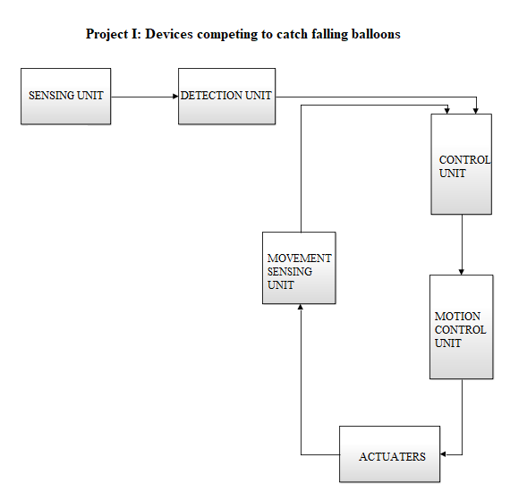

Figure 1 Block diagram of Project I

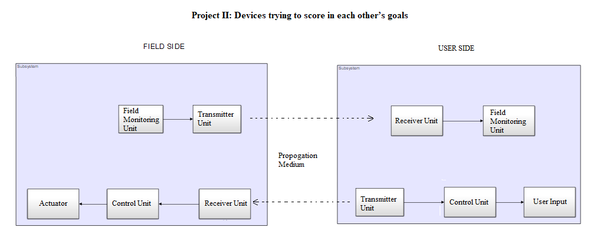

Figure 2 Block diagram of Project II

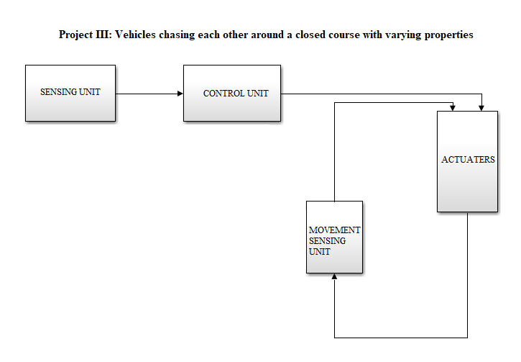

Figure 3 Block diagram of Project III

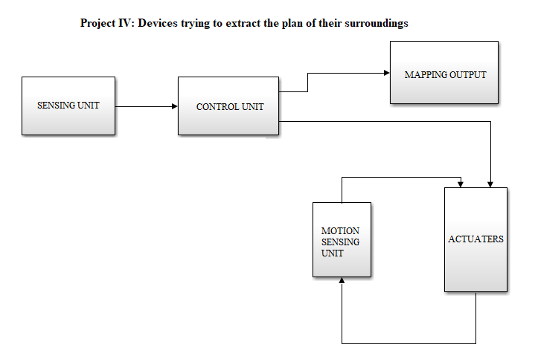

Figure 4 Block diagram of Project IV